**Joins Exercise**

**Learning Goal: understanding Joins**

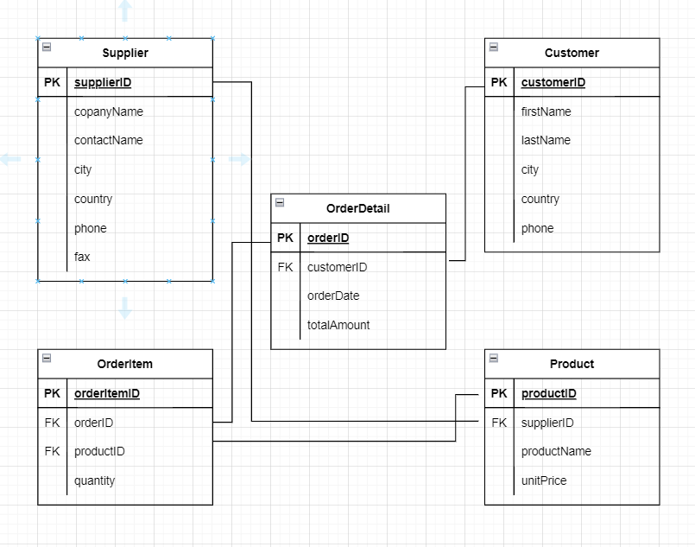

**Given the tables listed.**

1. **Write the SQL query to list all order dates with associated customer information.**

**SELECT Customer.*, orderDetail.orderDate**

**FROM Customer**

**LEFT JOIN orderDetail**

**WHERE Customer.customerID = orderDetail.customerID**

1. **List all products that have been ordered.**

**SELECT \***

**FROM Product**

**LEFT JOIN orderItem**

**WHERE Product.productID= orderItem.productID**

1. **List all suppliers and their products.**

**SELECT Supplier.*, Product.\***

**FROM Supplier**

**INNER JOIN Product**

**WHERE Supplier.supplierID = Product.supplierID**